CIVE 650C Assignment 1

Chenhui Liu

**Part 1**

Github:

Go through the presentation on Linux and git and do the following (Take snapshot at each for each of the below mentioned step and paste them in a word doc):

**1. Create a new repository on Github (make it public and initiate it with the READEM.md)**

Step 1: Go the Github website, and find the “New respository”

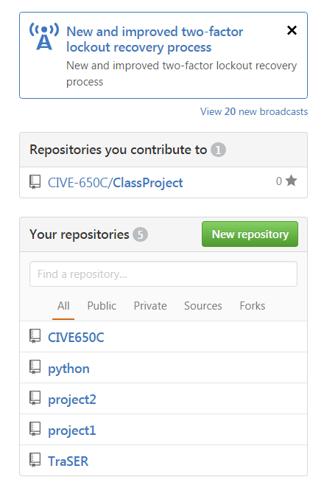

Step 2: create a new repository with initialization.

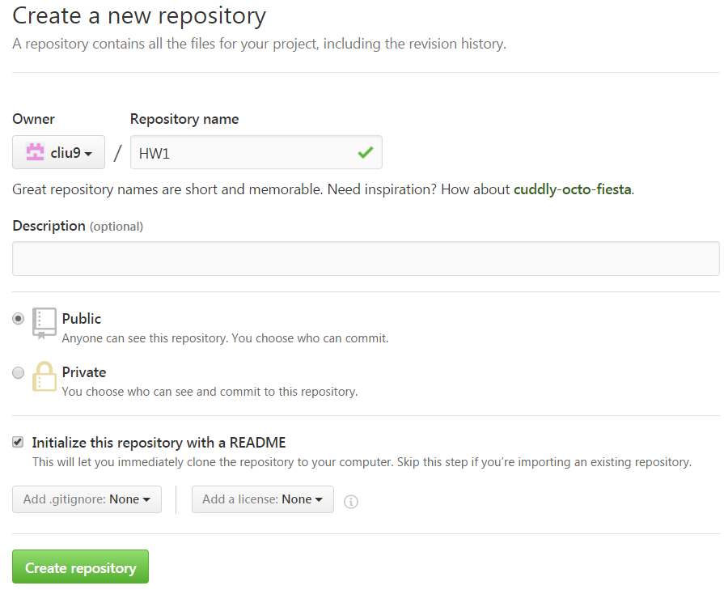

Step 3: results.

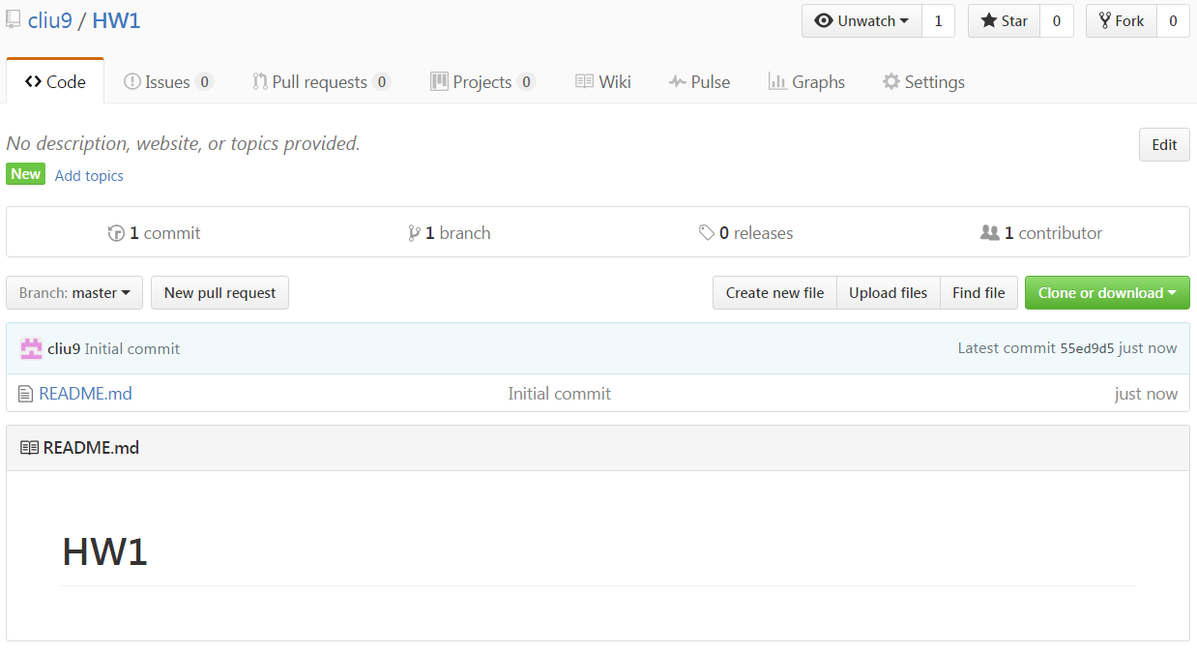

**2. Clone the repository (on the machine that was assigned to you)**

Step 1: copy the web URL of the repository.

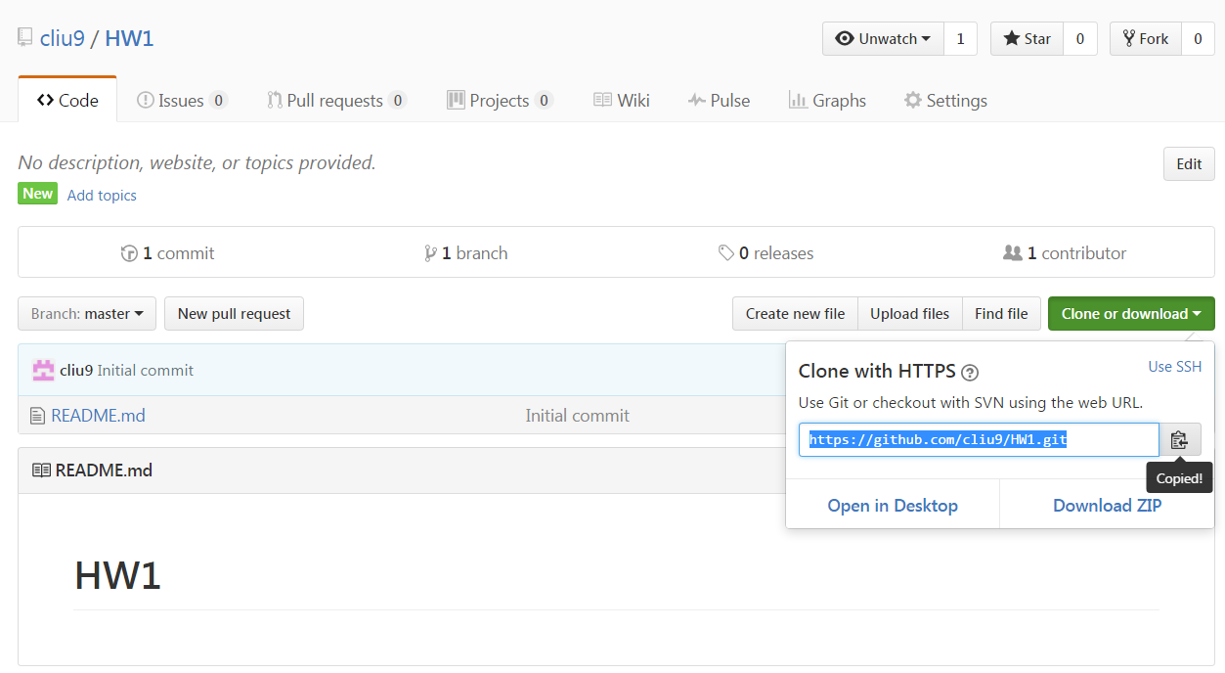

Step 2: clone the data on Linux.

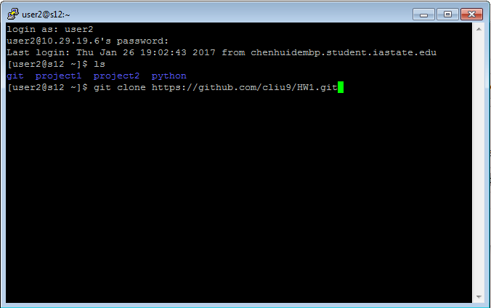

Step 3: results

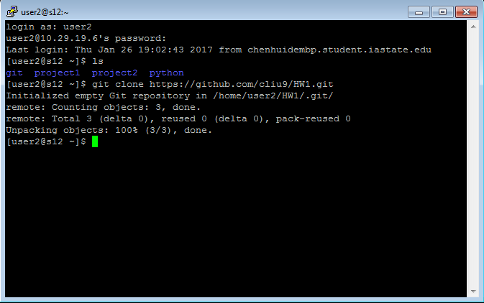

**3. Add a new file to this repository using the “vi editor”**

Step 1: go to the “HW1” repository

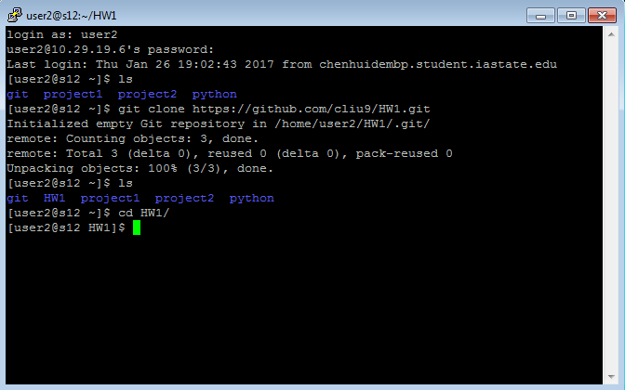

Step 2: open the “vi editor” and create a ‘test.md’ new file.

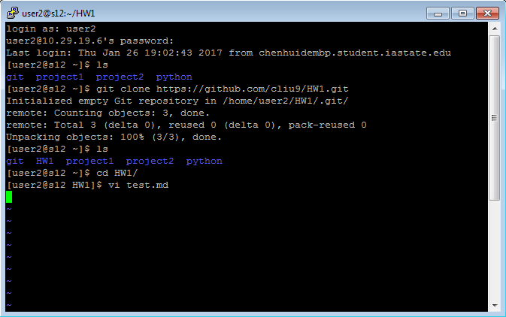

Step 3: add some words to the file.

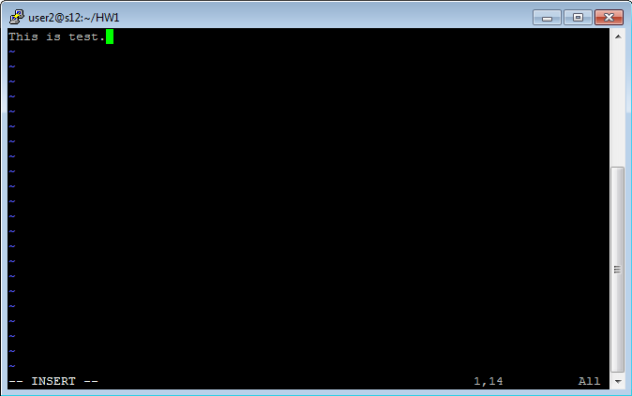  
Step 4: exit the vi editor.

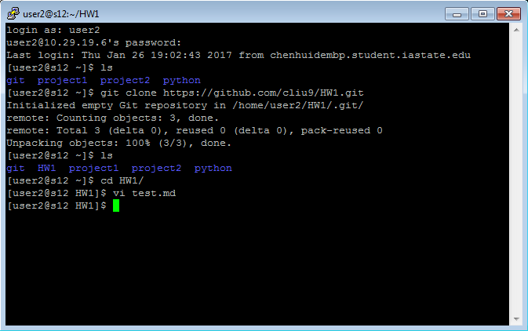

**4. Add the file to tracking.**

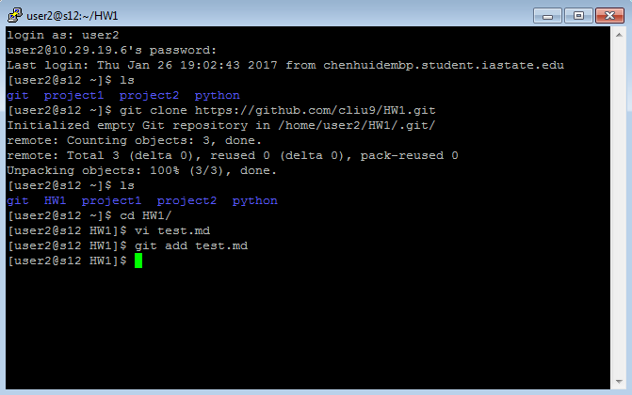

**5. Do a commit**

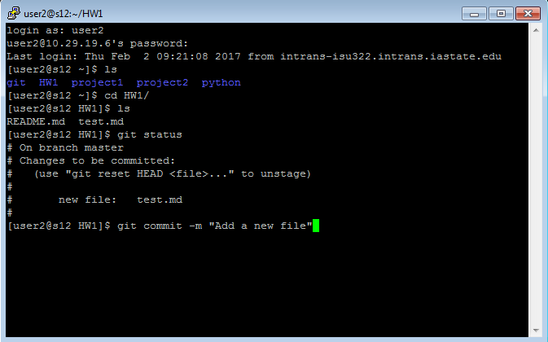

Results

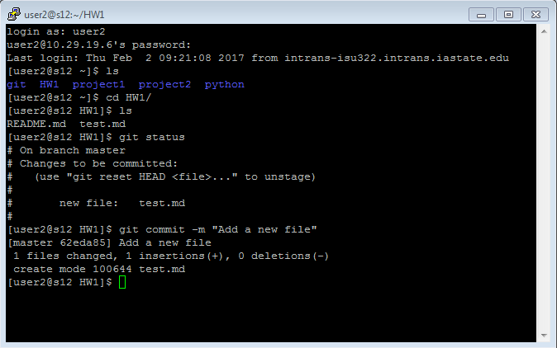

**6. Do a push to your Github account**

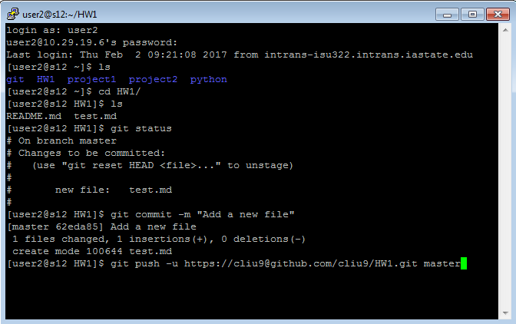

Results

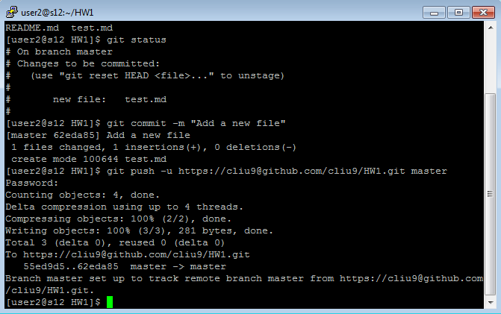

**7. Create a fix (add some lines) to some file in your local repository and do a git merge operation.**

Step 1: create a new branch “fix”

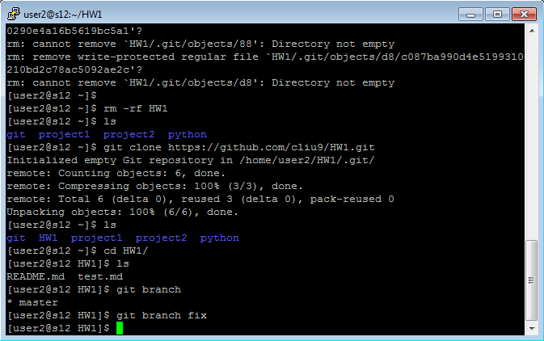

Step 2: switch to the new branch

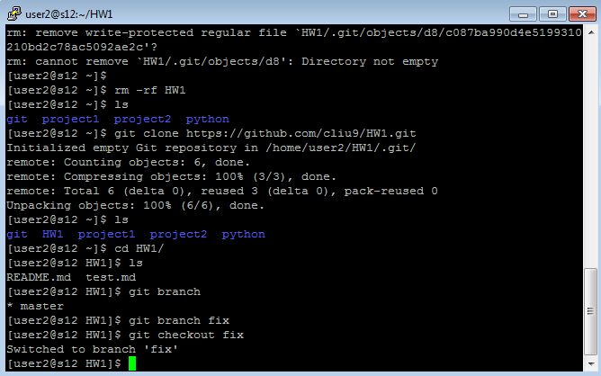

Step 3: add some new lines to the test.md by vi editor. Add “Iowa State University University of Iowa Northern Iowa University” to the file.

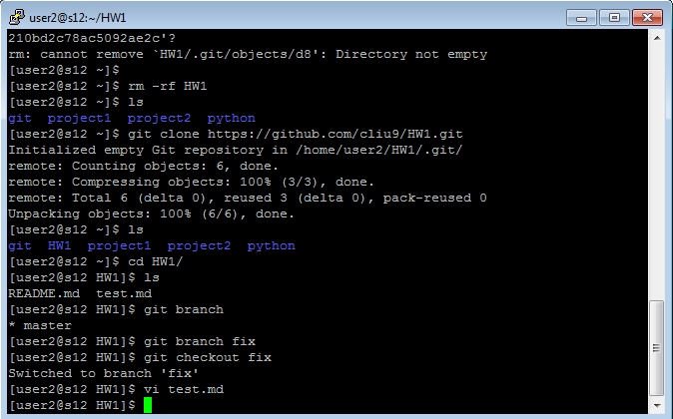

Step 4: commit, switch branch, and merge

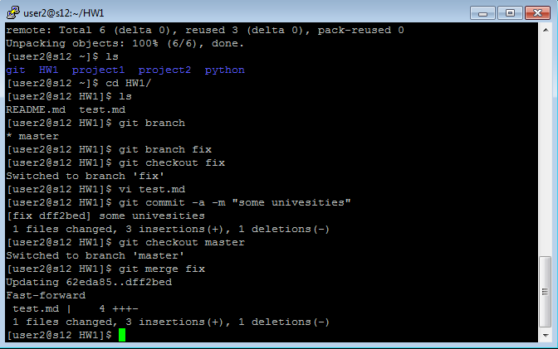

Step 5: delete the fix branch, and git push the changes to Github.

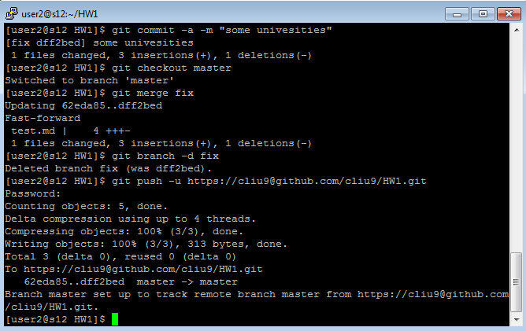

Step 6: Results

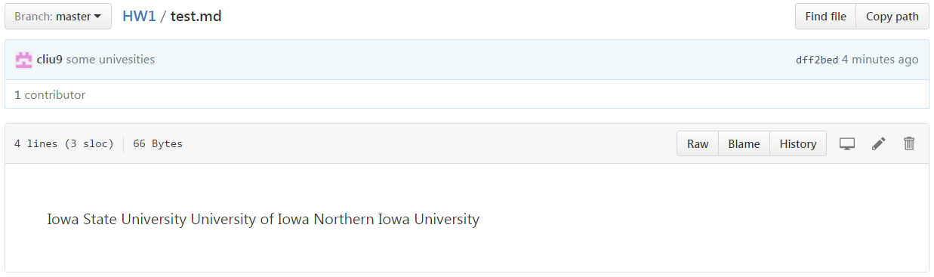

**Part 2**

**Seen in the attached ‘python_project’ folder.**

**Part 3**

**Seen in the attached ‘python_project’ folder.**